Amazon RDS Database and API GateWay and Lambda Function Integrations  
 Using ASP.NET CORE 8.0 Web Api Project

FOLLOW LINK: https://www.youtube.com/watch?v=58kZOQw-Bvk

Pre-requisites:

Install: AWS ToolKit

Packages:

Amazon.Lambda.AspNetCoreServer

Amazon.Lambda.AspNetCoreServer

StartUp.cs:

public void ConfigureServices(IServiceCollection services)

{

services.AddAWSLambdaHosting(LambdaEventSource.RestApi);

}

<Project Sdk="Microsoft.NET.Sdk.Web">

<PropertyGroup>

<TargetFramework>net8.0</TargetFramework>

<Nullable>enable</Nullable>

<ImplicitUsings>enable</ImplicitUsings>

<AWSProjectType>Lambda</AWSProjectType>

</PropertyGroup>

<ItemGroup>

<PackageReference Include="Amazon.Lambda.AspNetCoreServer" Version="9.0.0" />

<PackageReference Include="Amazon.Lambda.AspNetCoreServer.Hosting" Version="1.7.0" />

<PackageReference Include="Swashbuckle.AspNetCore" Version="6.4.0" />

<PackageReference Include="System.Data.SqlClient" Version="4.8.6" />

</ItemGroup>

</Project>

Go to AWS Management console.

Function Handler name is must be same as a solution name : RSAECRSAPI (my project Name)

Lambda : create lambda function

FunctionName:RSAECRSAPI

Runtime:.NET 8

Architecture: .x86_64

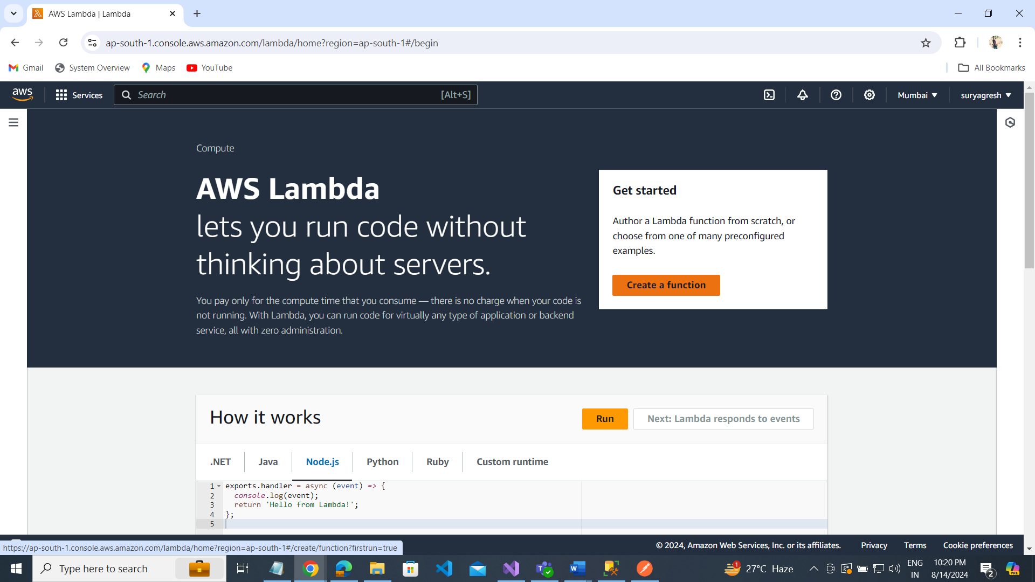

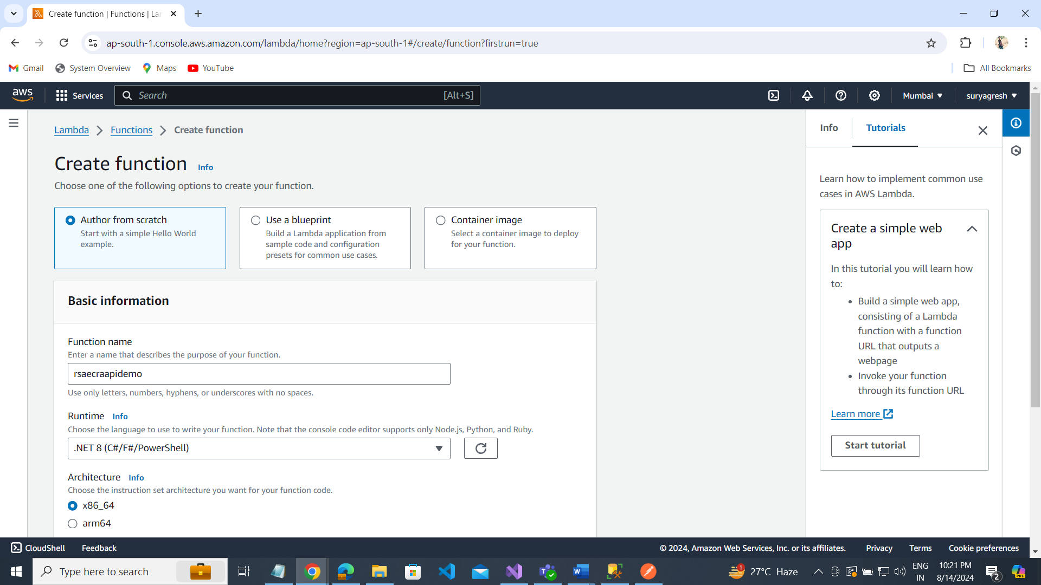

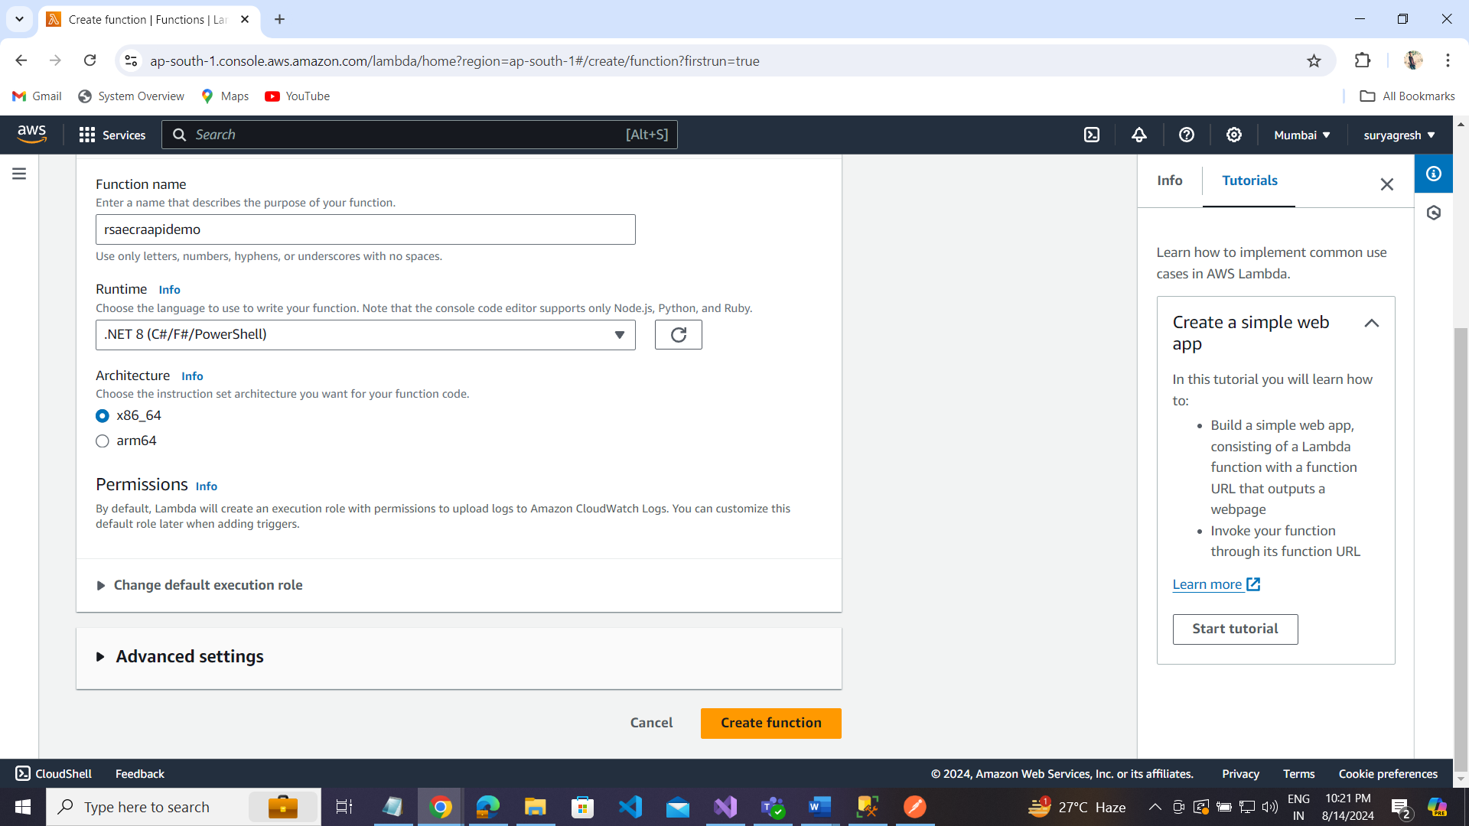

Click on Create function button.

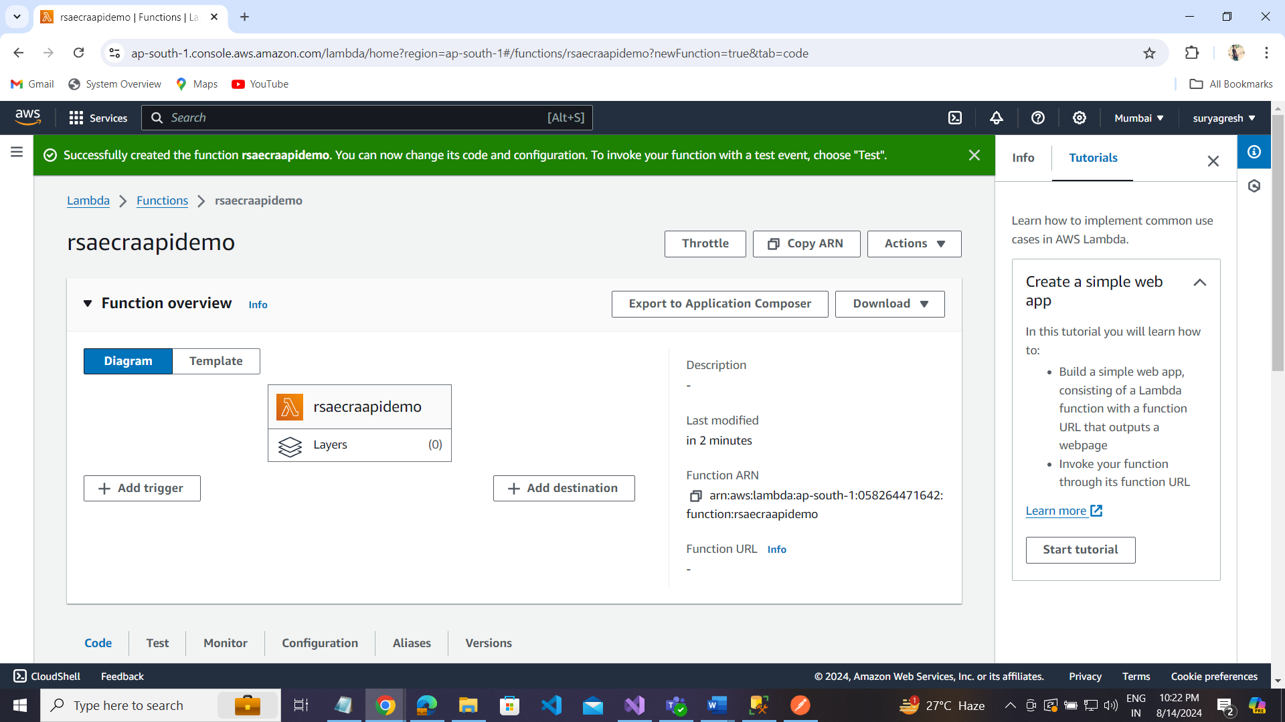

Go to your project code:

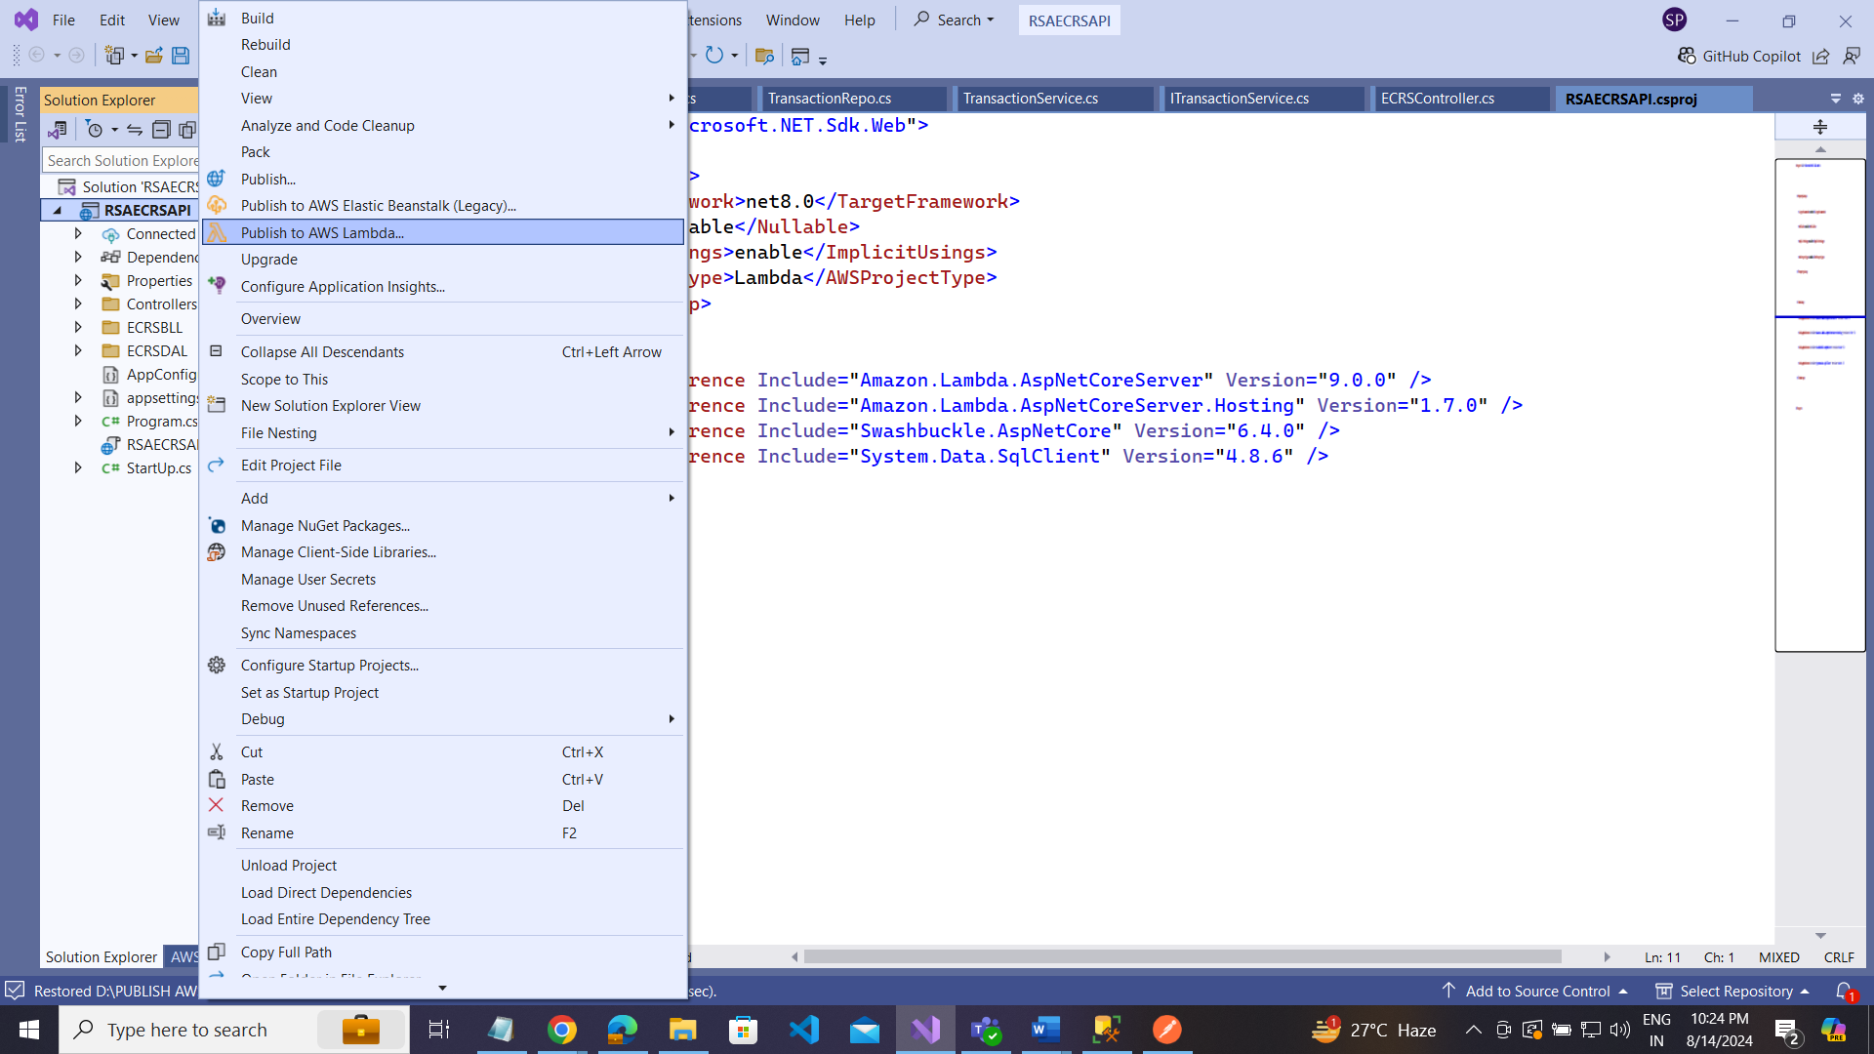

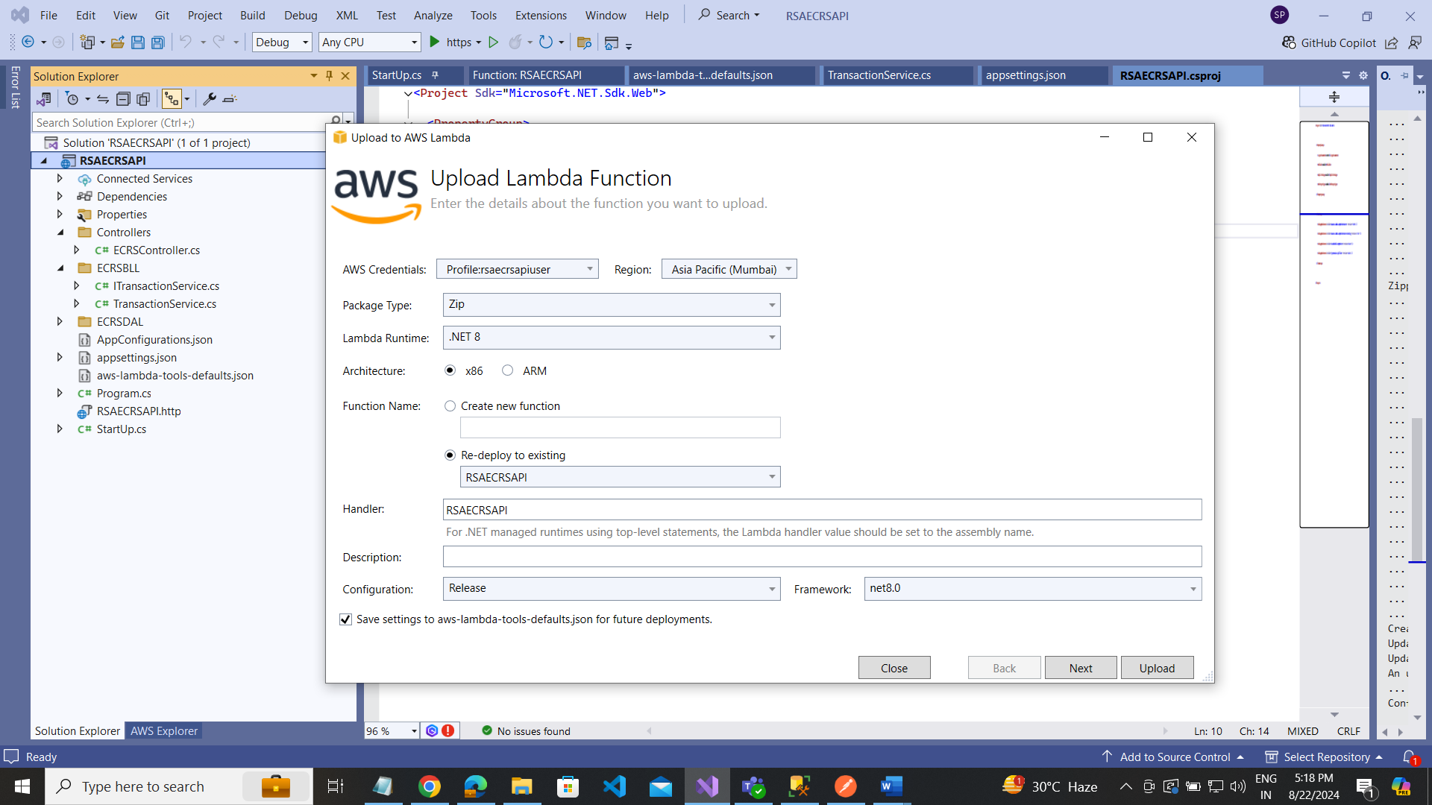

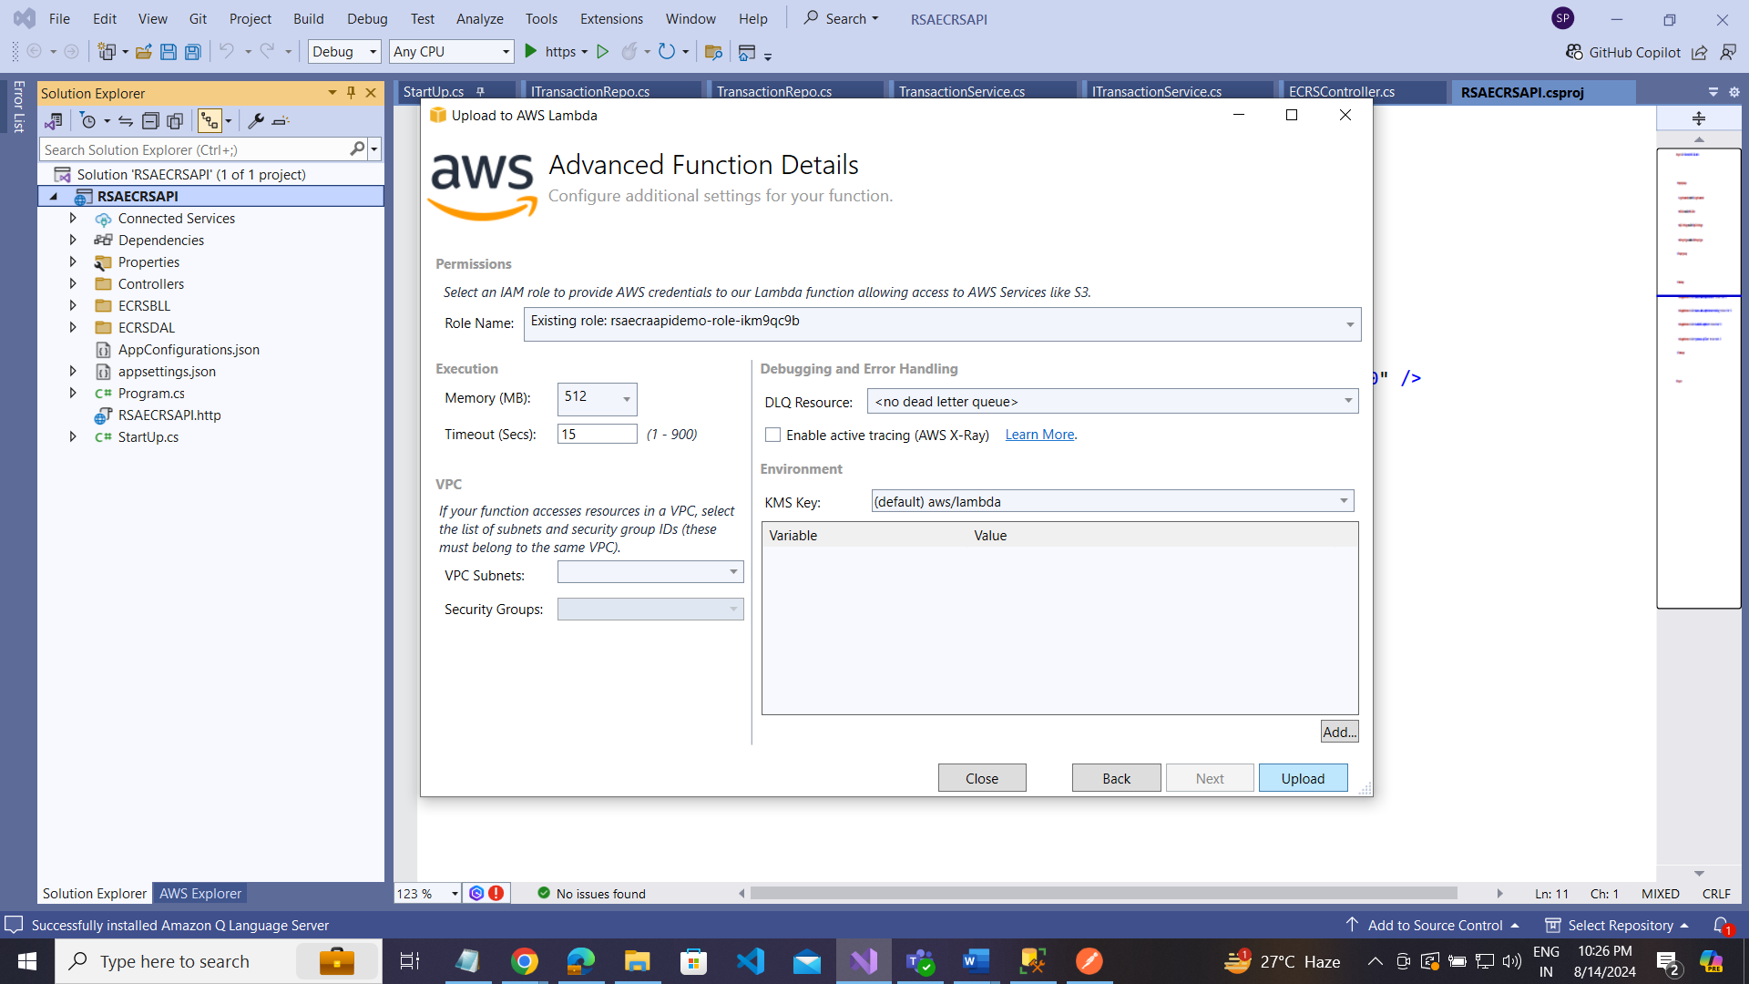

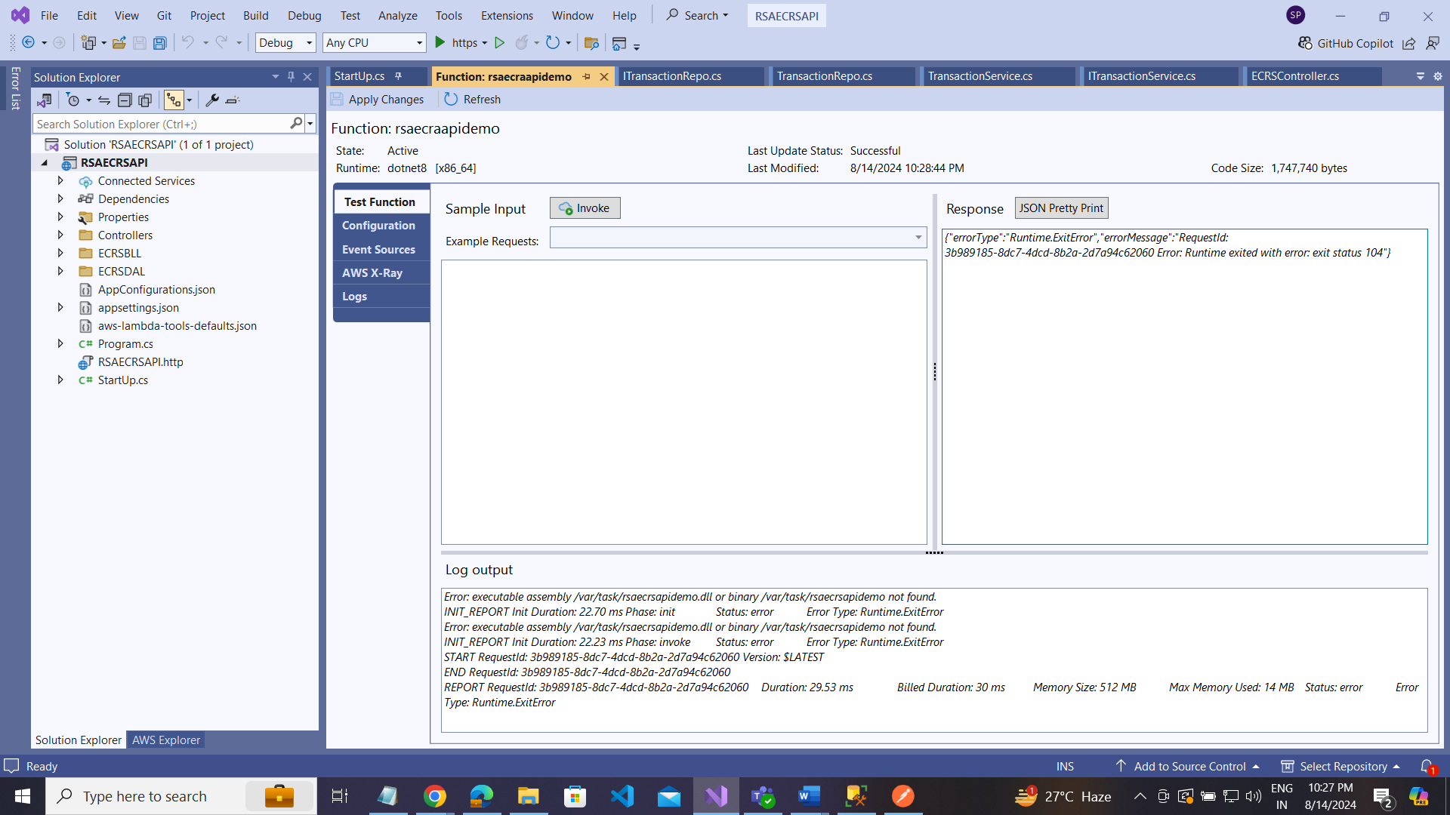

Go aws Lambd Function:

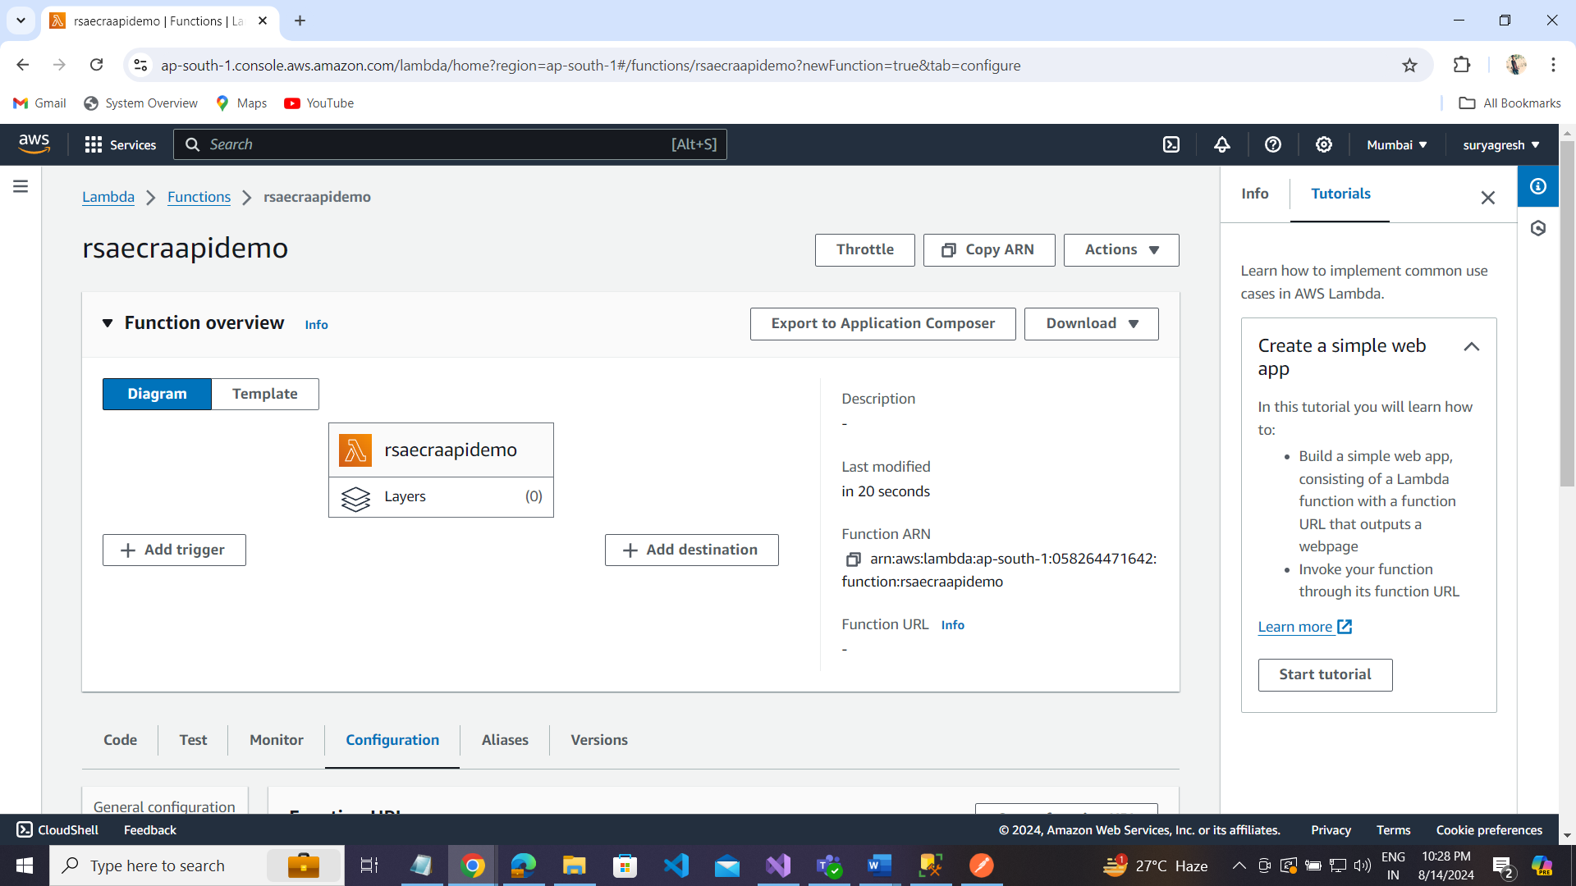

Go configuration: Create function URL

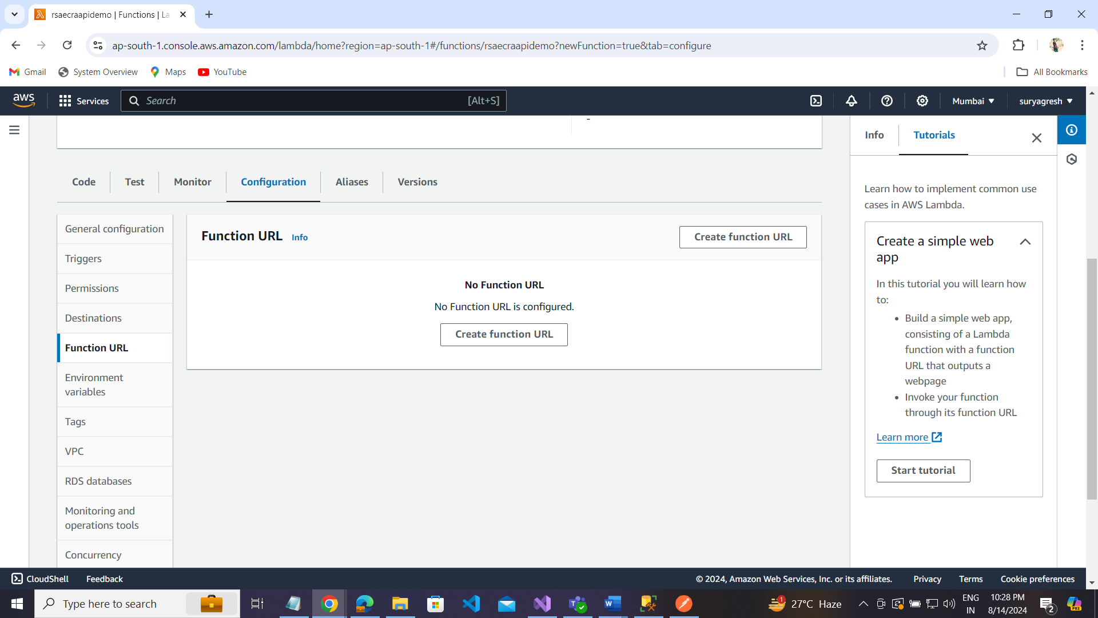

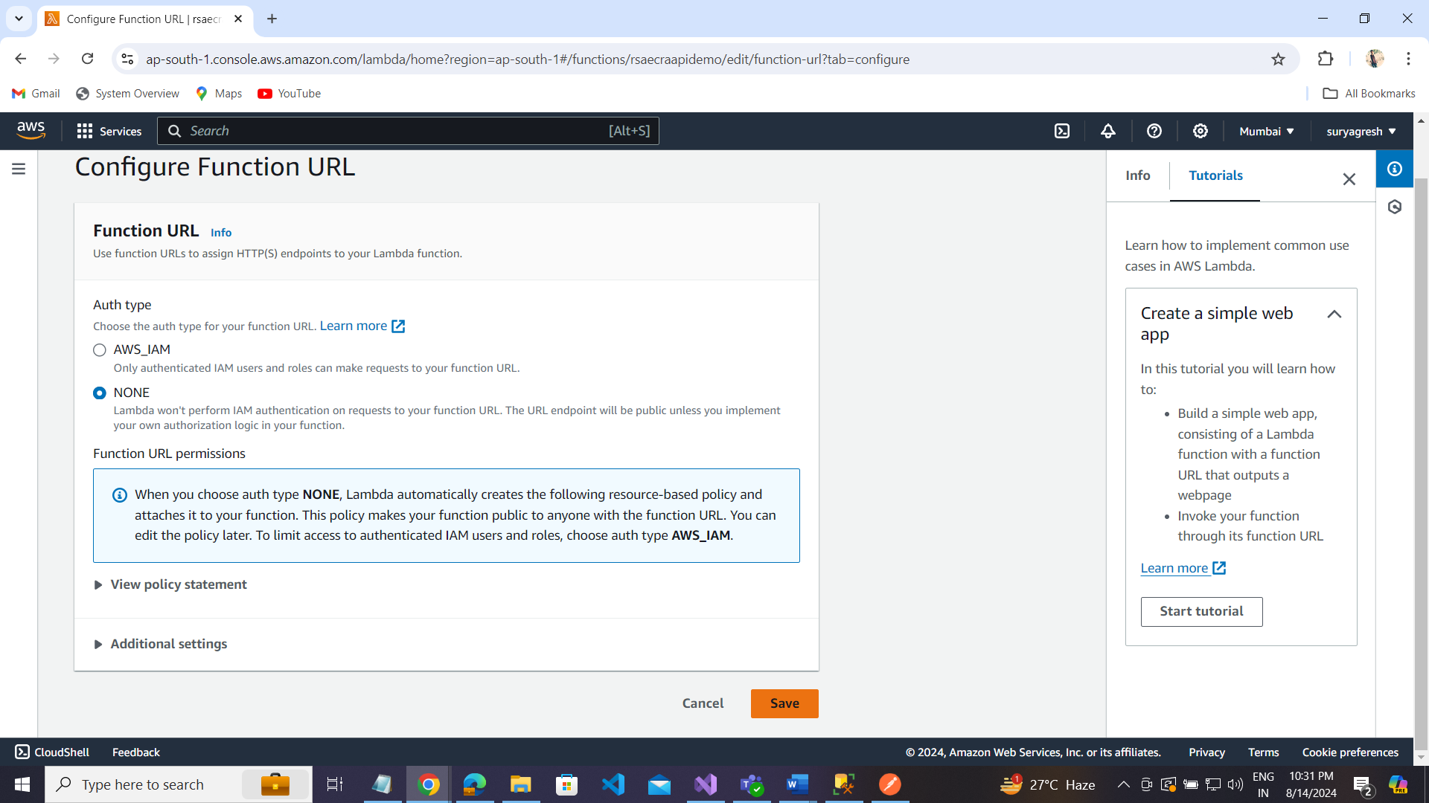

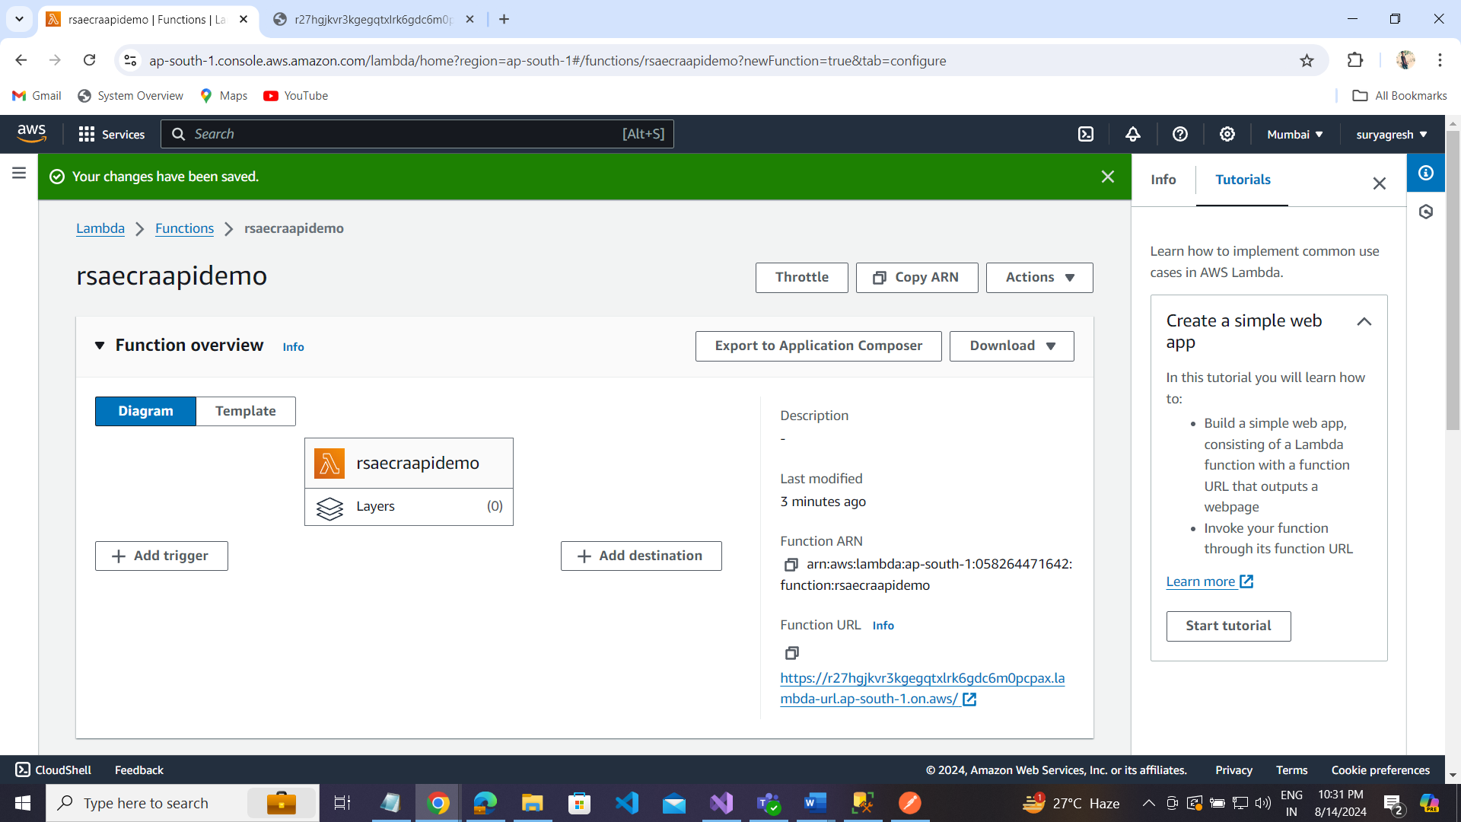

Function url: <https://r27hgjkvr3kgegqtxlrk6gdc6m0pcpax.lambda-url.ap-south-1.on.aws/>

Connect to Amazon RDS Database with Lambda Function Handlers:

Step1: Go to Configuration section  
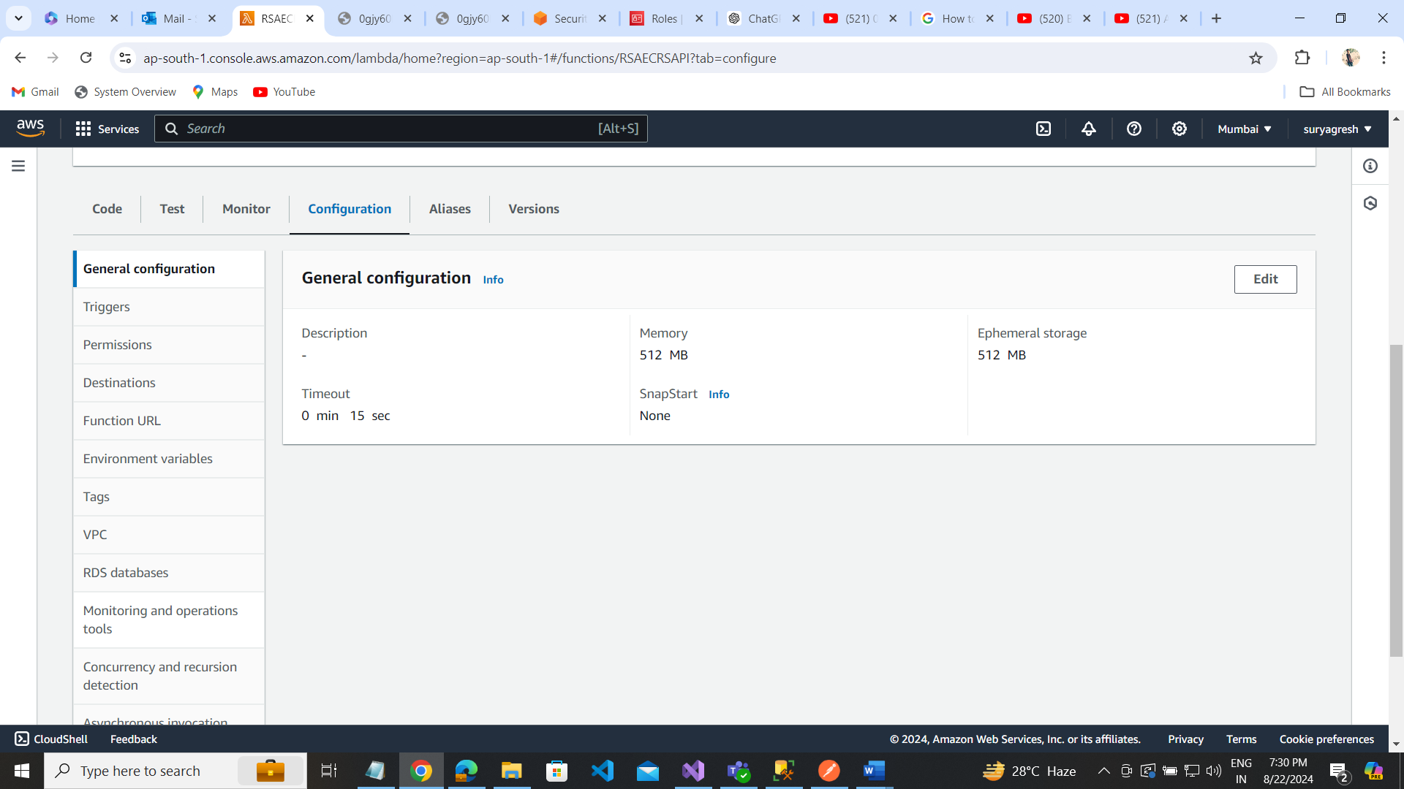

Step2: RDS databases  
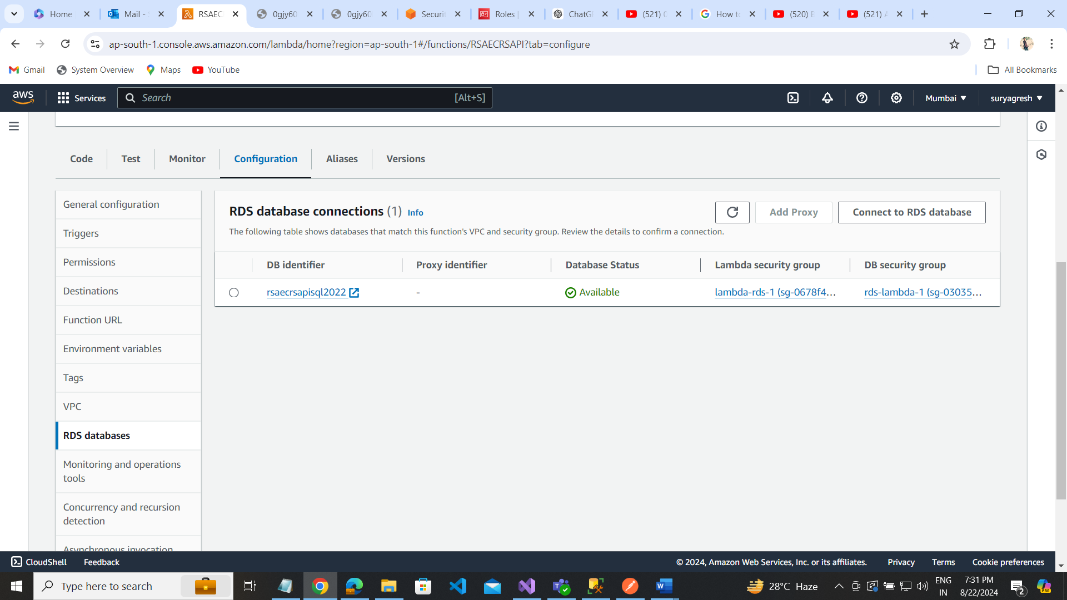

Step3 : Connect to RDS databases

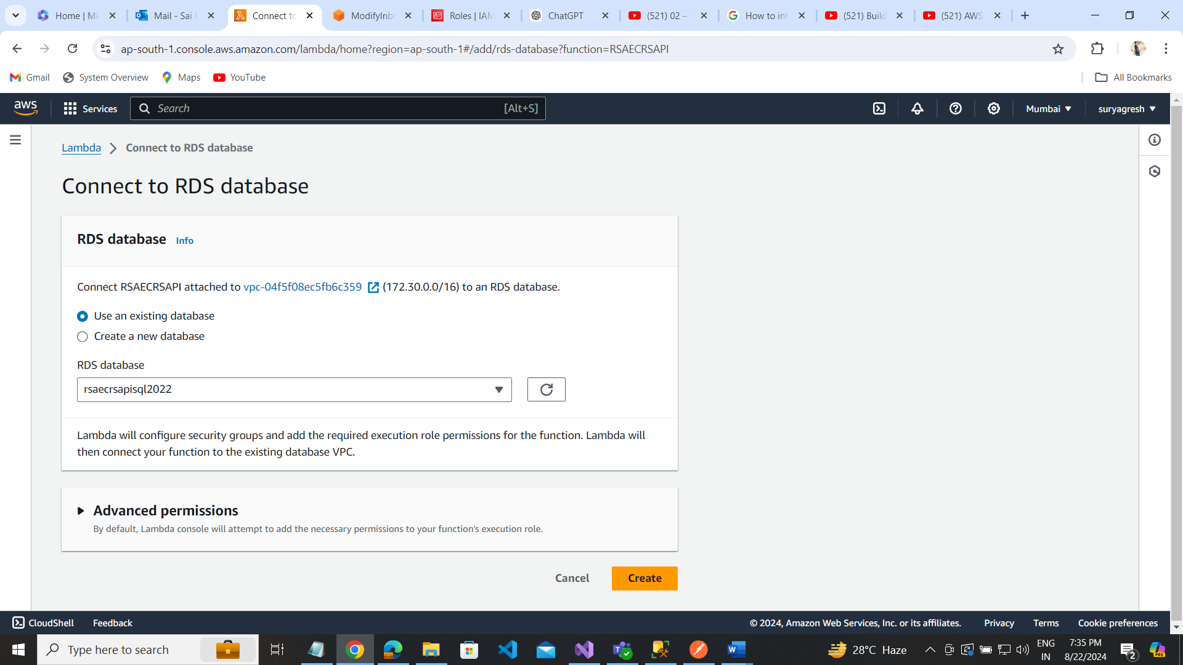

Click on the Create button.

Step4: select Lambda security group.

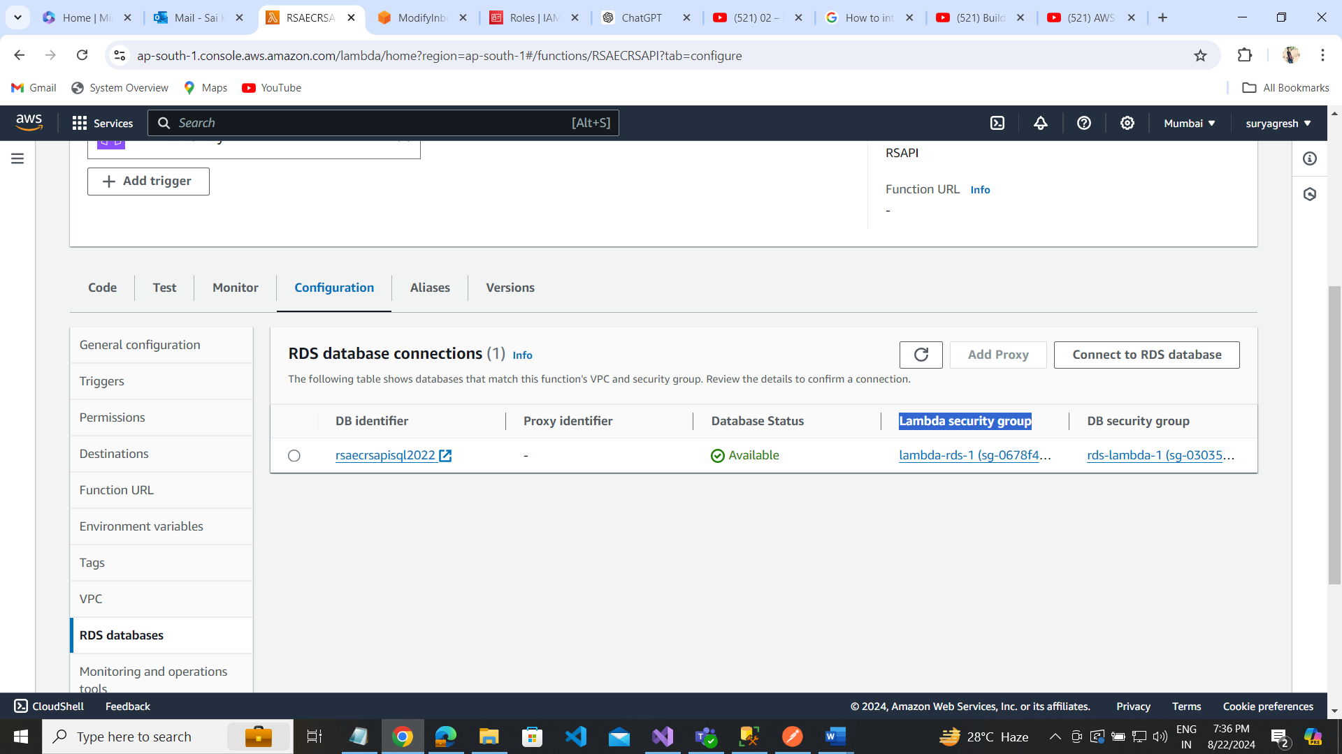 step5 : Edit inbound rules:

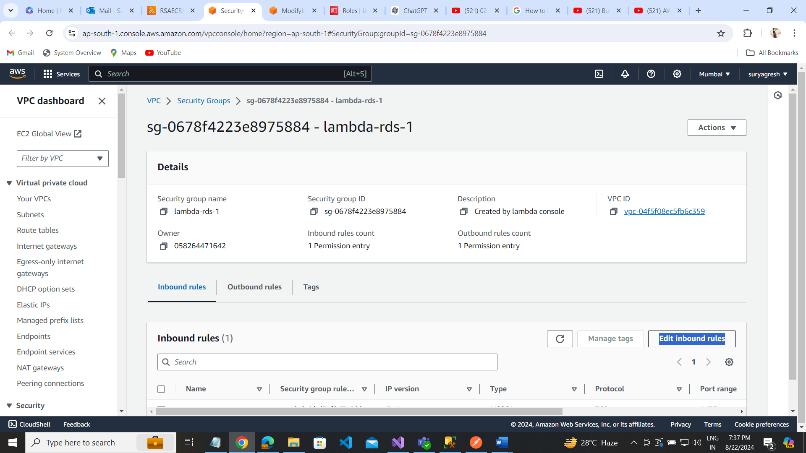

Step6: select Type : MSSQL and Source: MY IP --------------- save rules

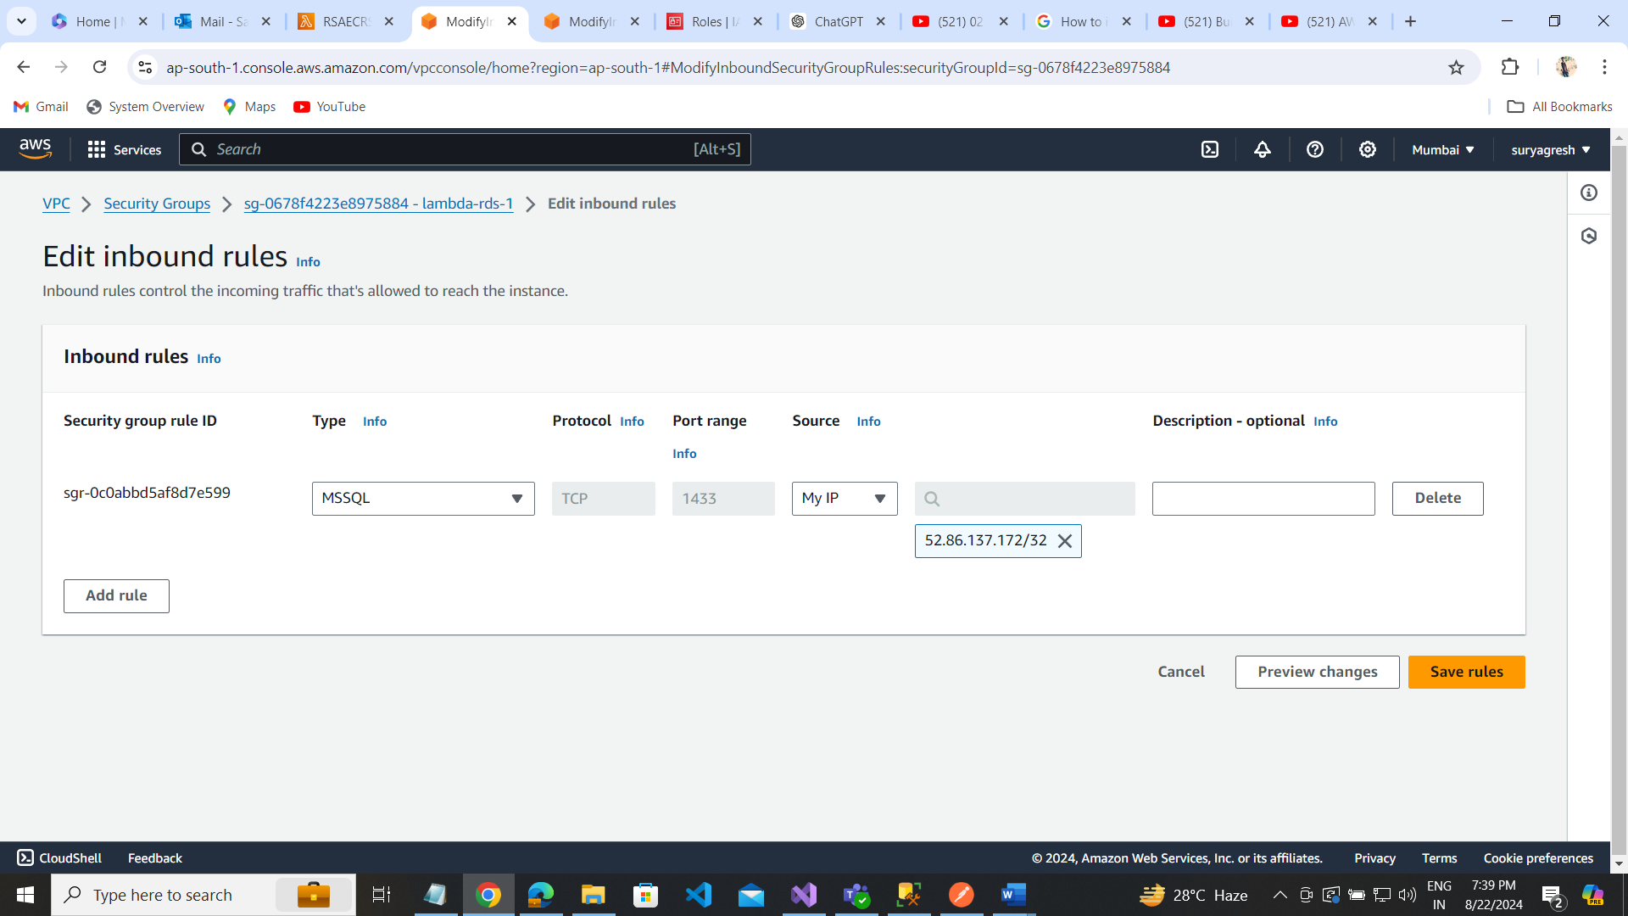

Then go to api gateway to create api .

Go API GATEWAY:  
Create api:

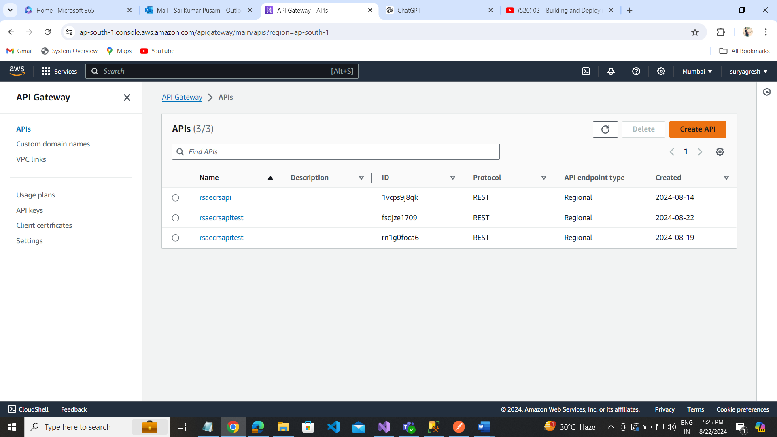

Choose Type: REST API

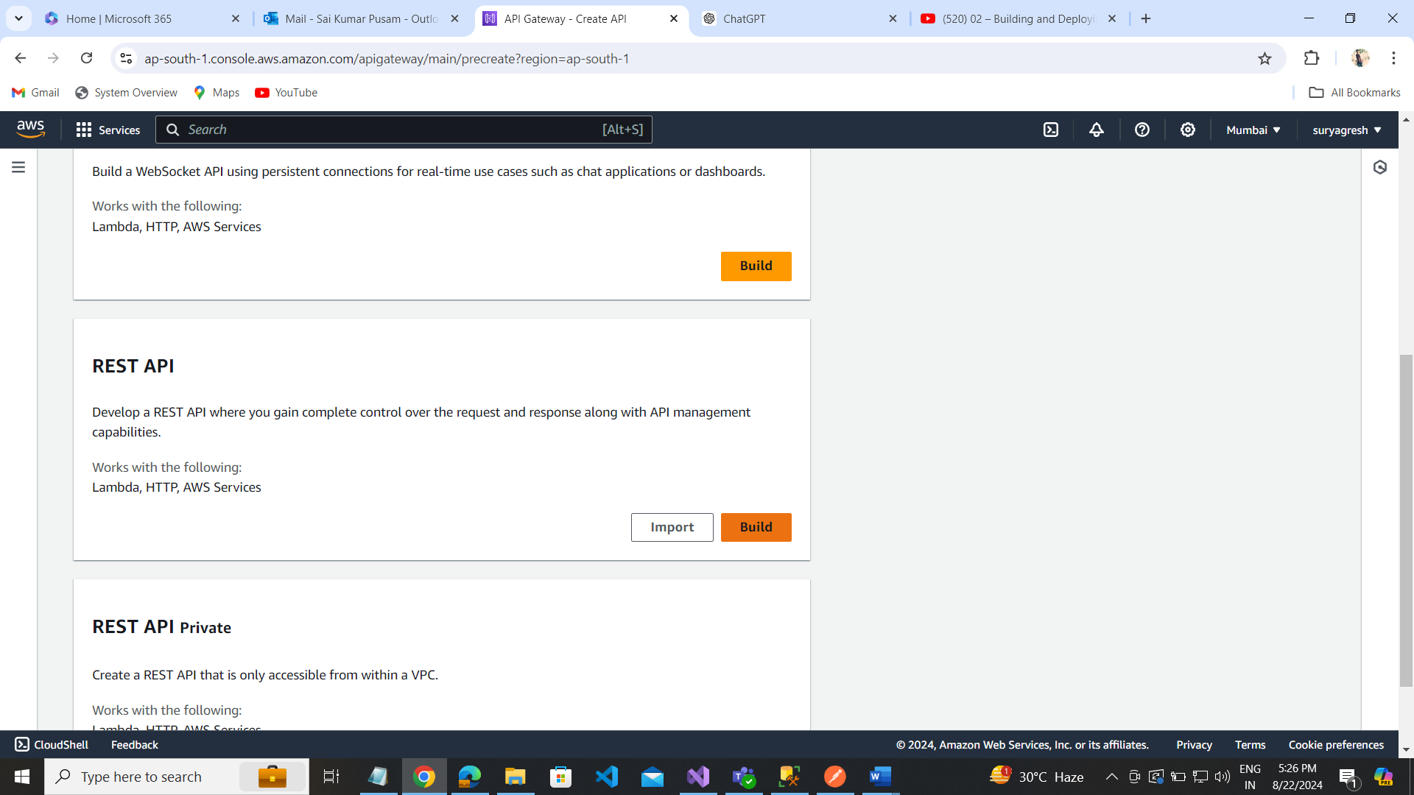

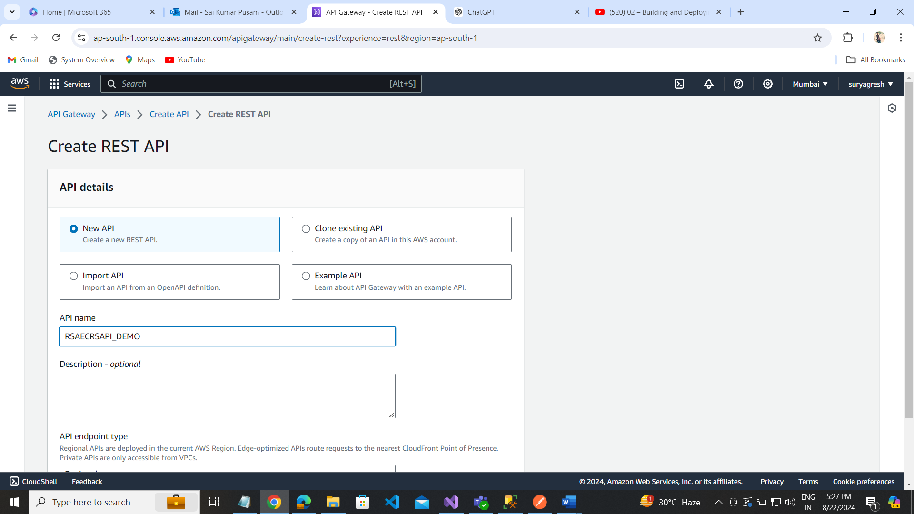

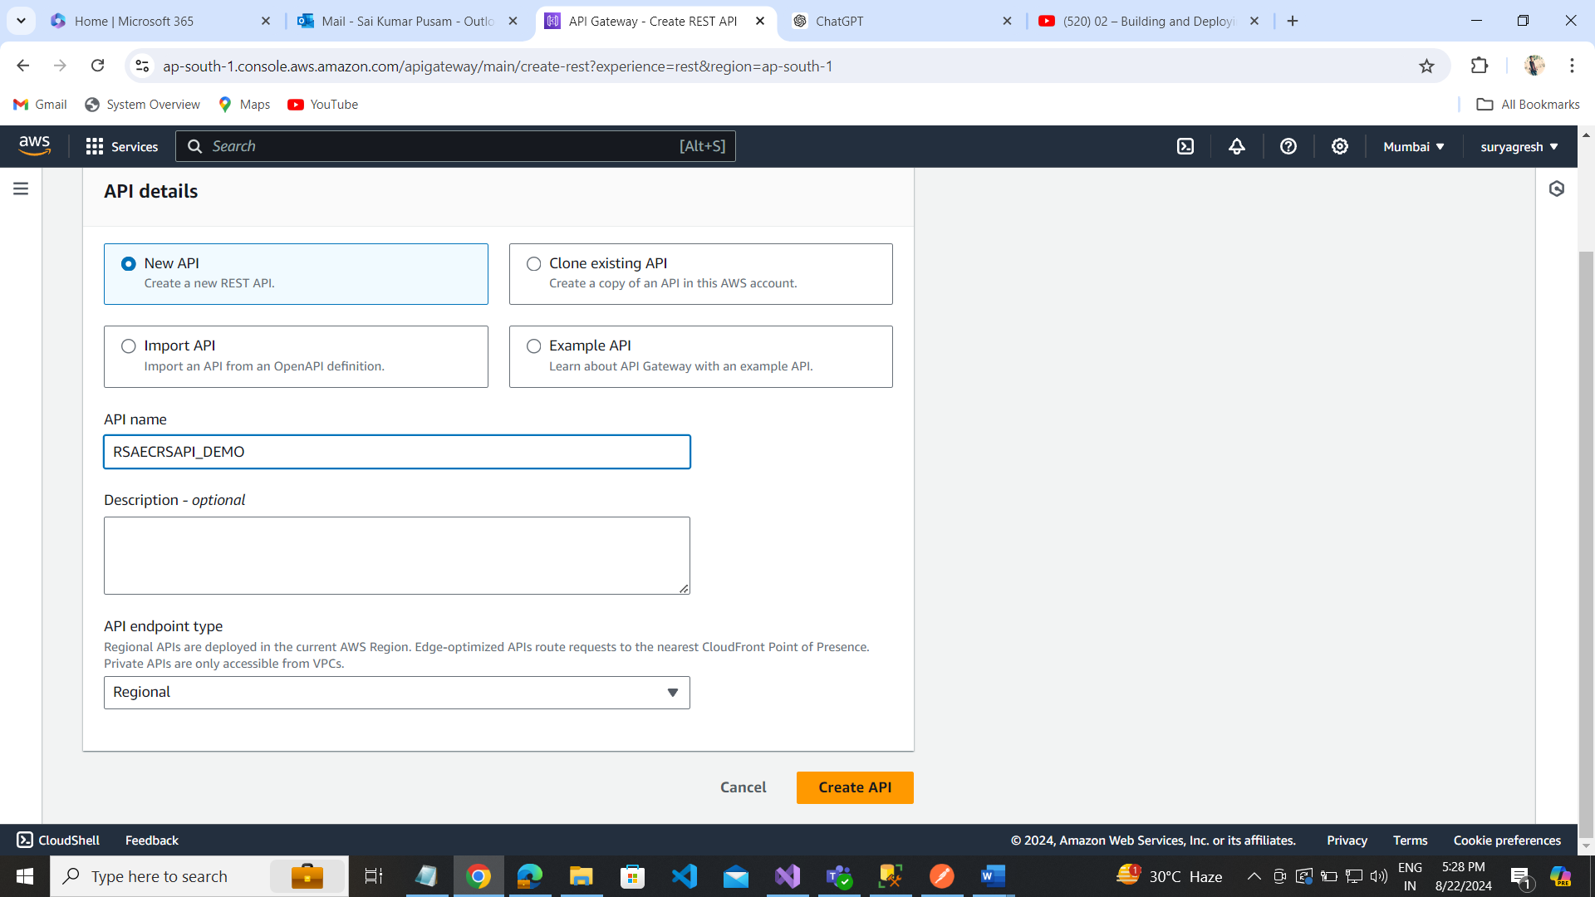

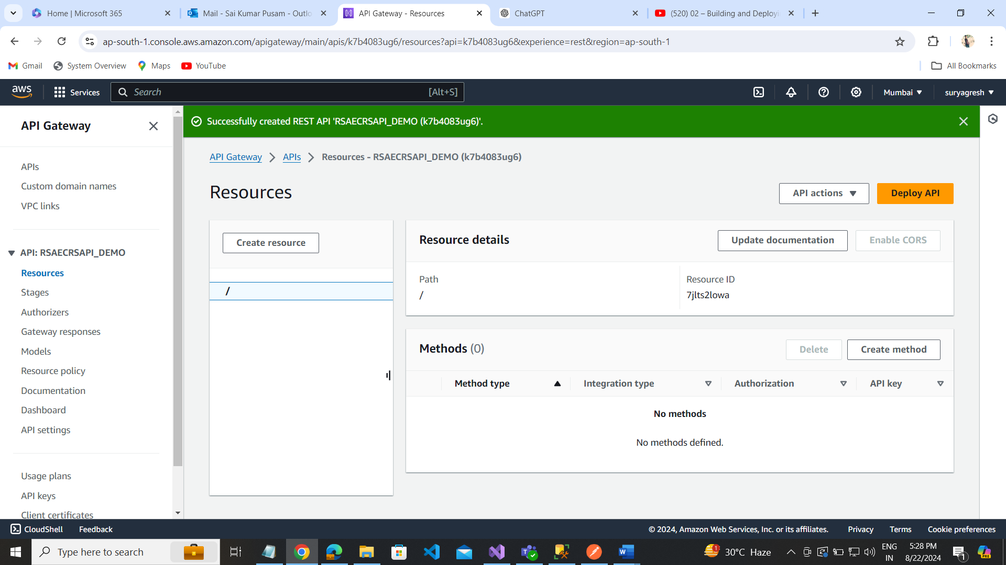

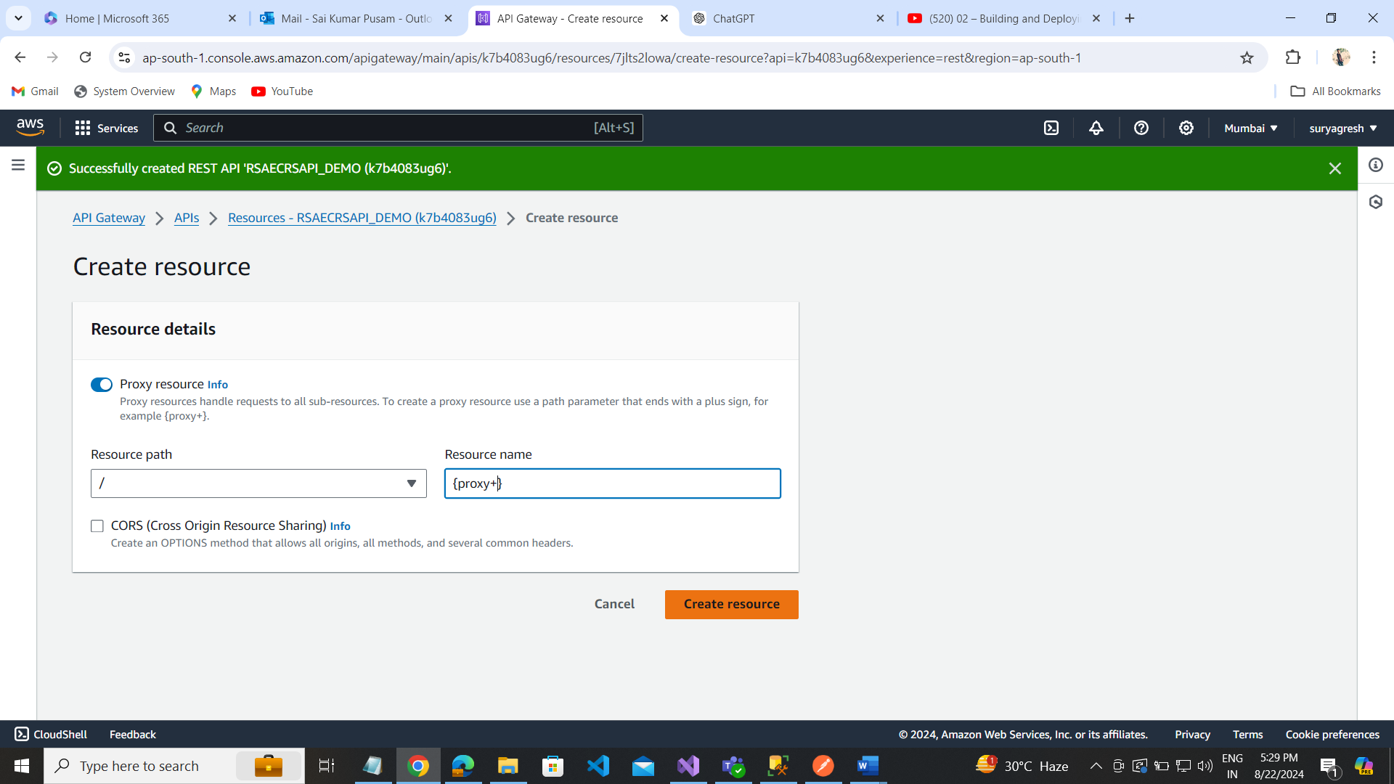

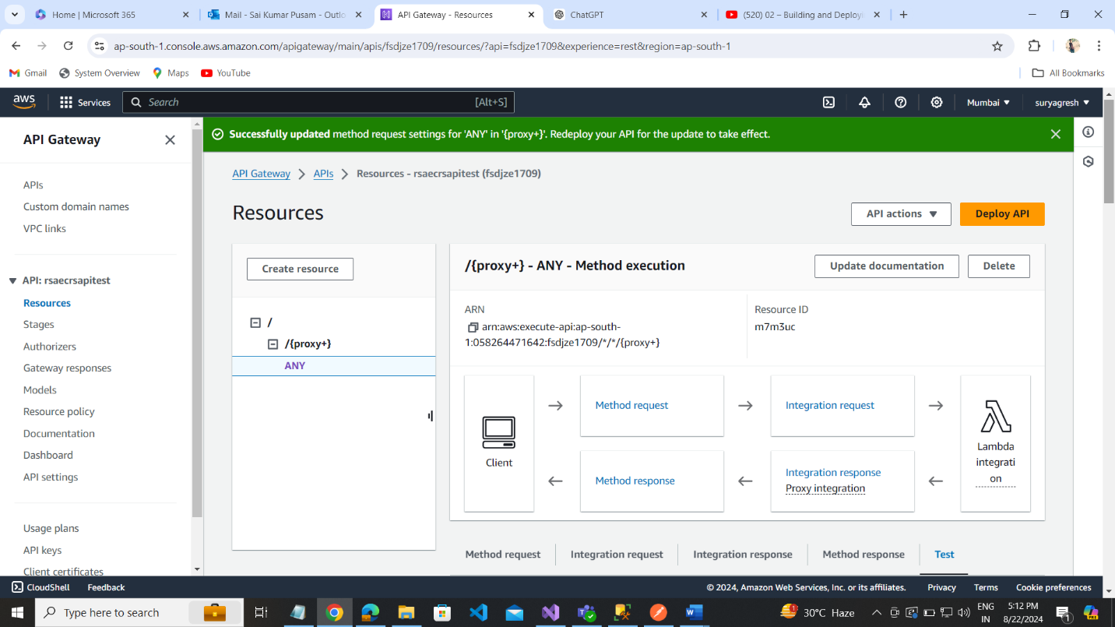

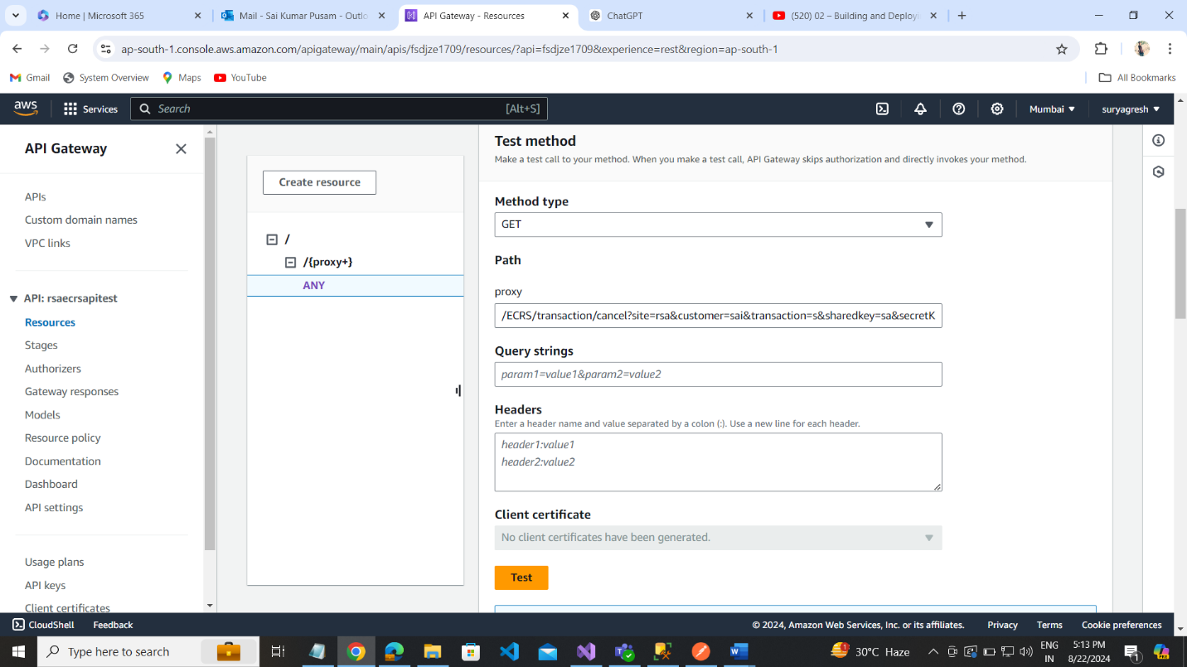

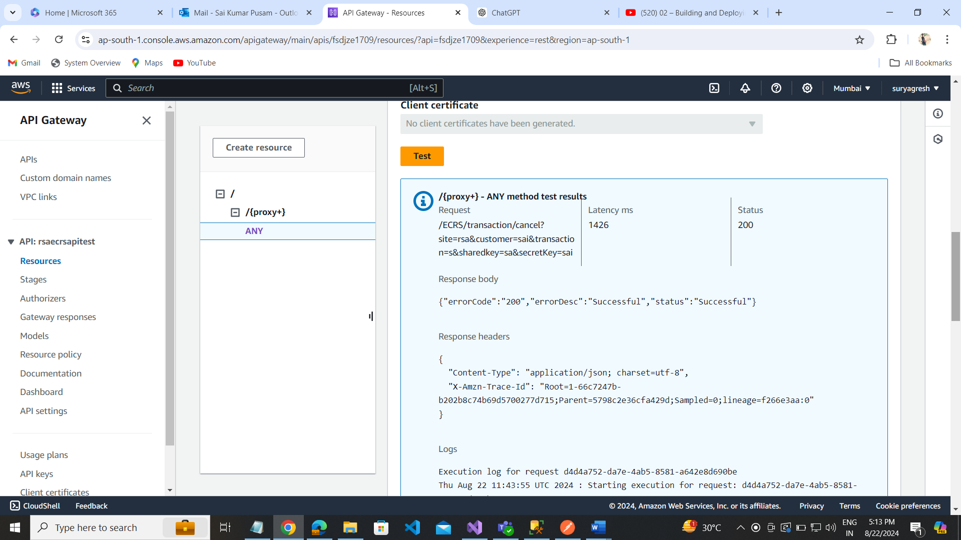

Deploy:

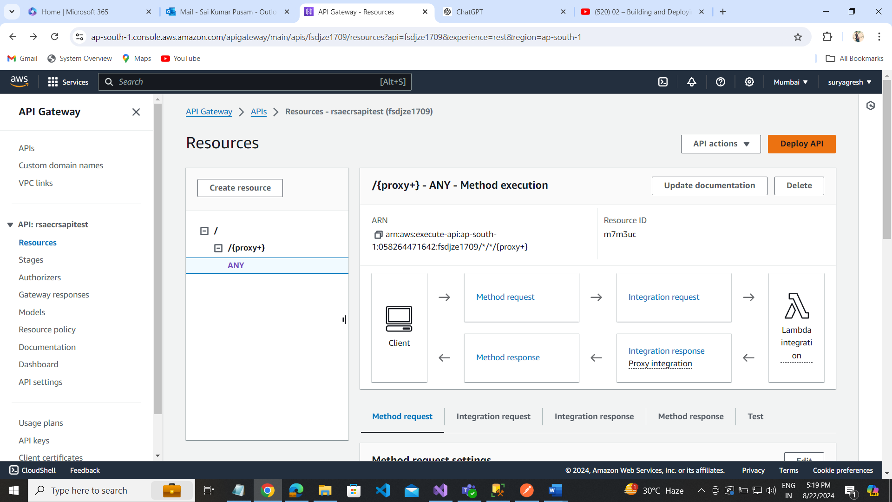

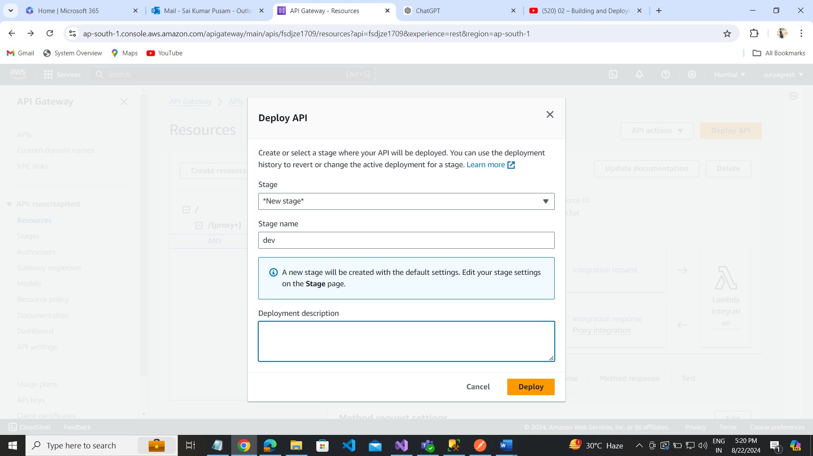

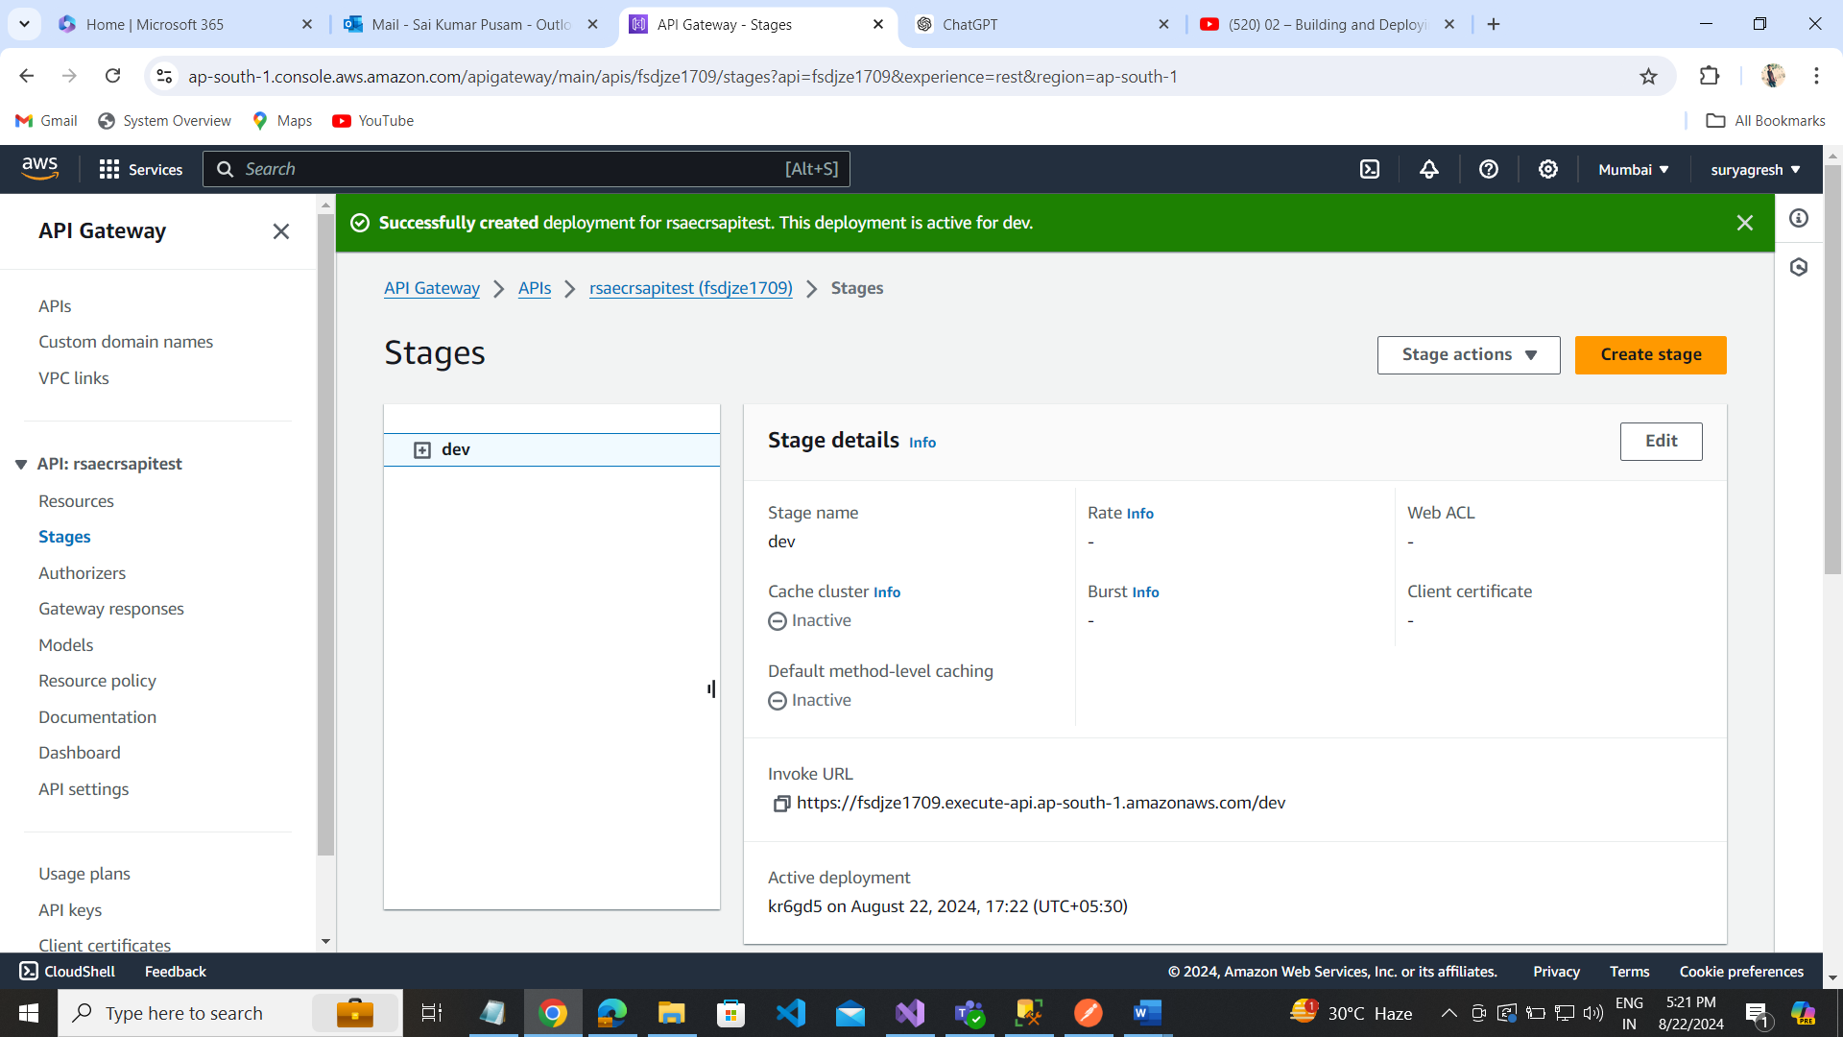

Test Invoke url:

<https://dwxrcghhi1.execute-api.ap-south-1.amazonaws.com/dev>

https://dwxrcghhi1.execute-api.ap-south-1.amazonaws.com/dev/ECRS/transaction/cancel?site=rsa&customer=sai&transaction=s&sharedkey=sa&secretKey=sai

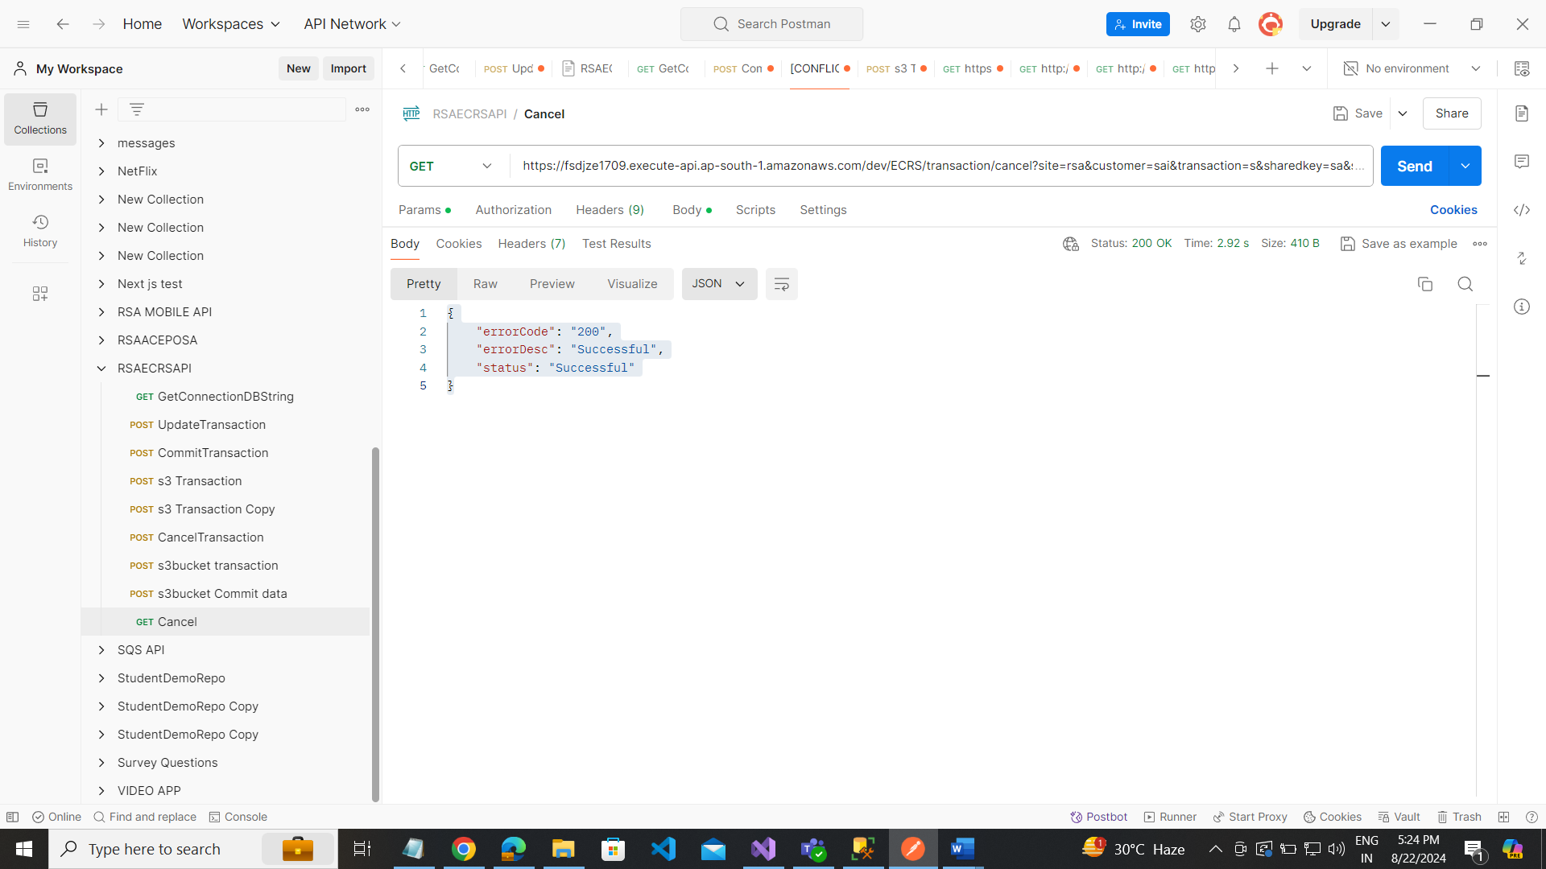

<https://dwxrcghhi1.execute-api.ap-south-1.amazonaws.com/dev/api/Student/StudentDetails>

student details from getting sql server database:

